Locality workers in Doncaster

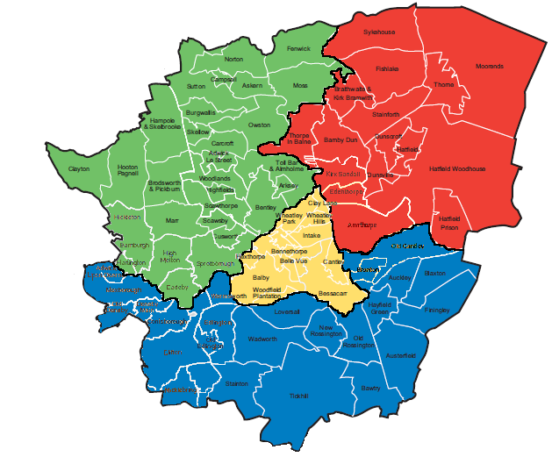
North West
Louise Doughty
07867373008
North East
Jenny Ford
07825781550
South
Alan Donald
07770657908

Central
Kelly Alexander
07717864321

